Prayers in Honor of the Seven Sundays of St. Joseph
Second Sunday
The Sorrow of the Poverty of Jesus’ Birth and the Joy of Seeing the Savior of the World
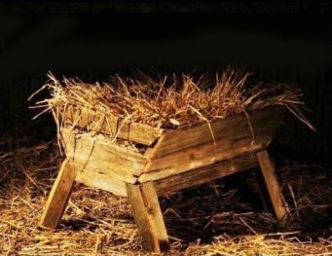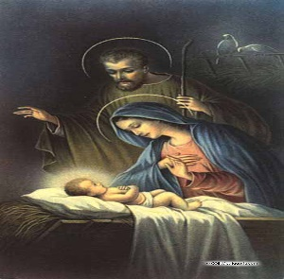
Reading Luke 2: 1, 4-7
In those days a decree went out from Caesar Augustus that all the world would be enrolled. This was the first enrollment, when Quirinius was governor of Syria. And all went to be enrolled, each to his own city. And Joseph also went up from Galilee, from the city of Nazareth to Judaea, to the city of David, which is called Bethlehem, because he was of the house and lineage of David, to be enrolled with Mary, his betrothed, who was with child. And while they were there, the time came for her to be delivered. And she gave birth to her firstborn Son and wrapped Him in swaddling clothes, and laid Him in a manger, because there was no room for them in the inn.
Meditation
“Journeying to Bethlehem for the census in obedience to the orders of legitimate authority, Joseph fulfilled for the child the significant task of officially inserting the name ‘Jesus, son of Joseph of Nazareth’ in the registry of the Roman Empire. This registration clearly shows that Jesus belongs to the human race as a man among men, a citizen of this world, subject to laws and civil institutions, but also ‘Savior of the World.’”
As guardian of the mystery ‘hidden for ages in the mind of God,’ which begins to unfold before his eyes ‘in the fullness of time,’ Joseph, together with Mary, is a privileged witness to the birth of the Son of God into the world on Christmas night in Bethlehem.
The mystery of the Incarnation is veiled in this humble scene. As St. Josemaria has written, “There is great simplicity about His birth. Our Lord comes without fanfare. No one knows about Him. On Earth, only Mary and Joseph share in the divine adventure. And then the shepherds who received the message from the angels. And later on, the wise men from the East. They were the only witnesses of this transcendental event which unites Heaven and Earth, God and man... The greatness of this Child who is God! His Father is the God who made Heaven and Earth; and there He is, in a manger, ‘because there was no room in the inn’—there was nowhere else for the Lord of all creation.”
Joseph loves Jesus and suffers seeing Him who he knows is the Word, the King of the universe, lying in a manger – a first announcement of that ‘self-emptying’ which Christ freely accepted for the forgiveness of sins. Joseph would give Jesus anything and everything, yet he has nothing to give. The difference between what he would like to do and his poverty places his soul in great distress. But then he grows calm. His sorrow recedes. He renews his dedication to God and carries out the divine command to love Jesus with his whole heart, with his whole soul, and with his whole strength. He gives himself completely to God who lies in his arms.

Litany of St. Joseph
Lord, have mercy. Lord, have mercy.
Christ, have mercy. Christ, have mercy.
Lord, have mercy. Lord, have mercy.
Christ, hear us. Christ, graciously hear us.
God the Father of Heaven, have mercy on us.
God the Son, Redeemer of the world, have mercy on us.
God the Holy Spirit, have mercy on us.
Holy Trinity, One God, have mercy on us.
Holy Mary, pray for us.
Saint Joseph, pray for us.
Illustrious son of David, etc. “
Light of the patriarchs, “
Spouse of the Mother of God, “
Chaste guardian of the Virgin, “
Foster-father of the Son of God, “
Watchful defender of Christ, “
Head of the Holy Family, “
Joseph most just, pray for us.
Joseph most chaste, “
Joseph most prudent, “
Joseph most valiant, “
Joseph most obedient, “
Joseph most faithful, “
Mirror of patience, pray for us.
Lover of poverty, “
Model of workers, “
Glory of domestic life, “
Guardian of virgins, “
Pillar of families, “
Solace of the afflicted, “
Hope of the sick, “
Patron of the dying, “
Terror of demons, “
Protector of Holy Church, “
Lamb of God, Who takes away the sins of the world, spare us, O Lord.
Lamb of God, Who takes away the sins of the world, graciously hear us, O Lord.
Lamb of God, Who takes away the sins of the world, have mercy on us.
V. He made him the lord of His household,
R. And prince over all His possessions.

Let us pray:
Blessed patriarch, glorious St. Joseph, chosen to serve as father of the Word made flesh, the sorrow which you felt when you saw the infant Jesus born into poverty was turned into heavenly joy when you saw the glory of that resplendent night. By this sorrow and this joy, we ask you to obtain for us that, after the course of this life, we hear angelic songs of praise and rejoice in the splendors of heavenly glory. Amen.

