Prayers in Honor of the Seven Sundays of St. Joseph
Sixth Sunday
The Sorrow of Joseph When He was Afraid to Return to his Homeland and his Joy on Being Told by the Angel to go to Nazareth.
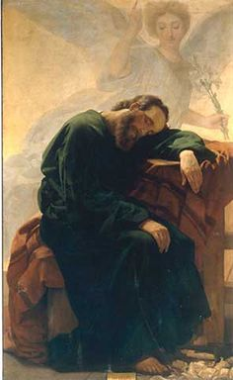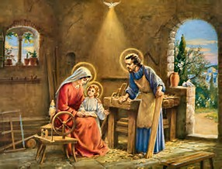
Reading Mt 2:19-23; Lk 2:40
But when Herod died, behold, an angel of the Lord appeared in a dream to Joseph in Egypt, saying, “Rise, take the Child and His Mother, and go to the land of Israel, for those who sought the Child’s life are dead.” And he rose and took the Child and His Mother, and went to the land of Israel. But when he heard that Archelaus reigned over Judea in place of his father Herod, he was afraid to go there, and being warned in a dream, he withdrew to the district of Galilee. And he went and dwelt in a city called Nazareth, that what was spoken by the prophets might be fulfilled, “He shall be called a Nazarene.”
And the Child grew and became strong, filled with wisdom; and the favor of God was upon Him.
Meditation
“Work was the daily expression of love in the life of the Family of Nazareth. The Gospel specifies the kind of work Joseph did in order to support his family: he was a carpenter. This simple word sums up Joseph’s entire life. For Jesus, these were hidden years, the years to which Luke refers after recounting the episode that occurred in the Temple. ‘And He went down with them and came to Nazareth, and was obedient to them.’ This ‘submission’ or obedience of Jesus in the house of Nazareth should be understood as a sharing in the work of Joseph. Having learned the work of His presumed father, He was known as ‘the carpenter’s son.’ If the Family of Nazareth is an example and model for human families, in the order of salvation and holiness, so too, by analogy, is Jesus’ work at the side of Joseph the carpenter. In our own day, the Church has emphasized this by instituting the liturgical memorial of St. Joseph the Worker on May 1. Human work, and especially manual labor, receives special prominence in the Gospel. Along with the humanity of the Son of God, work, too, has been taken up in the mystery of the Incarnation, and has also been redeemed in a special way. At the workbench where he plied his trade together with Jesus, Joseph brought human work close to the mystery of the Redemption.”

“In the human growth of Jesus ‘in wisdom, age, and grace,’ the virtue of industriousness played a notable role, since ‘work is a human good’ which ‘transforms nature’ and makes man ‘in a sense, more human.’”
“What is crucially important here is the sanctification of daily life, a sanctification which each person must acquire according to his or her own state, and one which can be promoted according to a model accessible to all people. ‘St. Joseph is the model of those humble ones that Christianity raises up to great destinies; . . . he is the proof that in order to be a good and genuine follower of Christ, there is no need of great things – it is enough to have the common, simple, and human virtues, but they must be authentic.’”

Litany of St. Joseph
Lord, have mercy. Lord, have mercy.
Christ, have mercy. Christ, have mercy.
Lord, have mercy. Lord, have mercy.
Christ, hear us. Christ, graciously hear us.
God the Father of Heaven, have mercy on us.
God the Son, Redeemer of the world, have mercy on us.
God the Holy Spirit, have mercy on us.
Holy Trinity, One God, have mercy on us.
Holy Mary, pray for us.
Saint Joseph, pray for us.
Illustrious son of David, “
Light of the patriarchs, “
Spouse of the Mother of God, “
Chaste guardian of the Virgin, “
Foster-father of the Son of God, “
Watchful defender of Christ, “
Head of the Holy Family, “
Joseph most just, pray for us.
Joseph most chaste, “
Joseph most prudent, “
Joseph most valiant, “
Joseph most obedient, “
Joseph most faithful, “
Mirror of patience, pray for us.
Lover of poverty, “
Model of workers, “
Glory of domestic life, “
Guardian of virgins, “
Pillar of families, “
Solace of the afflicted, “
Hope of the sick, “
Patron of the dying, “
Terror of demons, “
Protector of Holy Church, “
Lamb of God, Who takes away the sins of the world, spare us, O Lord.
Lamb of God, Who takes away the sins of the world, graciously hear us, O Lord.
Lamb of God, Who takes away the sins of the world, have mercy on us.
V. He made him the lord of His household,
R. And prince over all His possessions.
Let us pray: Glorious St. Joseph, you marveled to have the King of Heaven subject to your commands; though your consolation in leading Him out of Egypt was troubled by fear of Archelaus. Nevertheless, being reassured by the angel, you lived at Nazareth with Jesus and Mary. By this sorrow and this joy, obtain for us that our hearts be freed from harmful fears, and that we have peace of conscience living in security with Jesus and Mary and dying in their company. Amen.

