Prayers in Honor of the Seven Sundays of St. Joseph
Third Sunday
The Sorrow of the Circumcision and the Joy of the Holy Name of Jesus
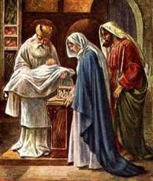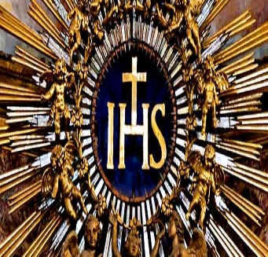
Reading Luke 2:21
And at the end of eight days, when He was circumcised, He was called Jesus, the name given by the angel before He was conceived in the womb.
Meditation
“A son’s circumcision was the first religious obligation of a father, and with this ceremony, Joseph exercised his right and duty with regard to Jesus.”
“The principle which holds that all the rites of the Old Testament are a shadow of the reality serves to explain why Jesus would accept them. As with all the other rites, circumcision too is ‘fulfilled’ in Jesus. God’s covenant with Abraham, of which circumcision was the sign, reaches its full effect and perfect realization in Jesus, who is the ‘yes’ of all the ancient promises.”
“At the circumcision, Joseph names the child ‘Jesus.’ This is the only name in which there is salvation. Its significance had been revealed to Joseph at the moment of his ‘annunciation’: “You shall call the child Jesus, for He will save His people from their sins.” In conferring the name, Joseph declares his own legal fatherhood over Jesus, and in speaking the name he proclaims the child’s mission as Savior.”

Litany of St. Joseph
Lord, have mercy. Lord, have mercy.
Christ, have mercy. Christ, have mercy.
Lord, have mercy. Lord, have mercy.
Christ, hear us. Christ, graciously hear us.
God the Father of Heaven, have mercy on us.
God the Son, Redeemer of the world, have mercy on us.
God the Holy Spirit, have mercy on us.
Holy Trinity, One God, have mercy on us.

Holy Mary, pray for us.
Saint Joseph, pray for us.
Illustrious son of David, etc. “
Light of the patriarchs, “
Spouse of the Mother of God, “
Chaste guardian of the Virgin, “
Foster-father of the Son of God, “
Watchful defender of Christ, “
Head of the Holy Family, “
Joseph most just, pray for us.
Joseph most chaste, “
Joseph most prudent, “
Joseph most valiant, “
Joseph most obedient, “
Joseph most faithful, “
Mirror of patience, pray for us.
Lover of poverty, “
Model of workers, “
Glory of domestic life, “
Guardian of virgins, “
Pillar of families, “
Solace of the afflicted, “
Hope of the sick, “
Patron of the dying, “
Terror of demons, “
Protector of Holy Church, “
Lamb of God, Who takes away the sins of the world, spare us, O Lord.
Lamb of God, Who takes away the sins of the world, graciously hear us, O Lord.
Lamb of God, Who takes away the sins of the world, have mercy on us.
V. He made him the lord of His household,
R. And prince over all His possessions.
Let us pray:
Obedient follower of the law of God, glorious St. Joseph, the precious blood which flowed at the circumcision of the infant Jesus caused your heart to be pierced, but the name of Jesus gave new life and filled you with peace. By this sorrow and this joy, obtain for us that by struggling against the slavery of sin, we may die in joy with the Most Holy Name of Jesus in our hearts and on our lips. Amen.

