Prayers in Honor of the Seven Sundays of St. Joseph
Fifth Sunday
The Sorrow of the Flight into Egypt and the Joy of Living in the Company of Jesus and Mary
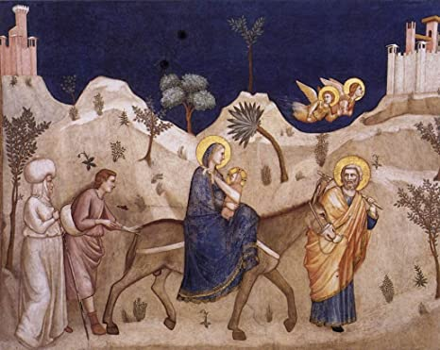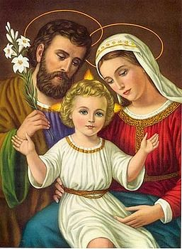
Reading Mt 2: 13-15
Behold, an angel of the Lord appeared to Joseph in a dream and said, “Rise, take the Child and His Mother and flee to Egypt, and remain there until I tell you, for Herod is about to search for the Child to destroy Him. And Joseph rose and took the Child and His Mother by night, and departed to Egypt, and remained there until the death of Herod. This was to fulfill what the Lord had spoken by the prophets, “Out of Egypt have I called My Son.
Meditation
St. John Chrysostom comments on this scene: “On hearing this, Joseph was not shocked, nor did he say: ‘This is strange. You yourself made it known not long ago that He would save His people, and now you are incapable even of saving Him—we have to flee, to set out on a long journey and spend a long while in a strange place; that contradicts your promise.’ Joseph does not think in this way, for he is a man who trusts God. Nor does he ask when he will return, ever, though the angel left that time vague: "Stay there until I tell you to return." Joseph does not object; he obeys and believes and joyfully accepts all the trials. St. Joseph faithfully fulfills God's will. St. Josemarίa adds, “The Gospels give us a picture of St. Joseph as a remarkably sound man who was in no way frightened or scared of life. On the contrary, he faced up to problems, dealt with difficult situations and showed responsibility and initiative in whatever he was asked to do. I don't agree with the traditional picture of St. Joseph as an old man, even though it may have been prompted by a desire to emphasize the perpetual virginity of Mary. I see him as a strong young man, perhaps a few years older than Our Lady, but in the prime of his life and work. You don't have to wait to be old or lifeless to practice the virtue of chastity. Purity comes from love; and the strength and gaiety of youth are no obstacle for noble love. Joseph had a young heart and a young body when he married Mary, when he learned of the mystery of her divine motherhood, when he lived in her company, respecting the integrity God wished to give the world.”
“The Church deeply venerates the Family and proposes it as the model of all families. Inserted directly in the mystery of the Incarnation, the Family of Nazareth has its own special mystery. And in this mystery, as in the Incarnation, one finds a true fatherhood: the human form of the family of the Son of God, a true human family, formed by the divine mystery. In this family, Joseph is the father: his fatherhood is not one that derives from begetting offspring; but neither is it an ‘apparent’ or merely ‘substitute’ fatherhood. Rather it is one that fully shares in authentic human fatherhood and the mission of a father in the family. This is a consequence of the hypostatic union: humanity taken up into the unity of the Divine Person of the Word – Son, Jesus Christ. Together with human nature, all that is human and especially the family – as the first dimension of man’s existence in the world – is also taken up in Christ. Within this context, Joseph’s human fatherhood was also ‘taken up’ in the mystery of Christ’s Incarnation.”

Litany of St. Joseph
Lord, have mercy. Lord, have mercy.
Christ, have mercy. Christ, have mercy.
Lord, have mercy. Lord, have mercy.
Christ, hear us. Christ, graciously hear us.
God the Father of Heaven, have mercy on us.
God the Son, Redeemer of the world, have mercy on us.
God the Holy Spirit, have mercy on us.
Holy Trinity, One God, have mercy on us.
Holy Mary, pray for us.
Saint Joseph, pray for us.
Illustrious son of David, “
Light of the patriarchs, “
Spouse of the Mother of God, “
Chaste guardian of the Virgin, “
Foster-father of the Son of God, “
Watchful defender of Christ, “
Head of the Holy Family, “
Joseph most just, pray for us.
Joseph most chaste, “
Joseph most prudent, “
Joseph most valiant, “
Joseph most obedient, “
Joseph most faithful, “
Mirror of patience, pray for us.
Lover of poverty, “
Model of workers, “
Glory of domestic life, “
Guardian of virgins, “
Pillar of families, “
Solace of the afflicted, “
Hope of the sick, “
Patron of the dying, “
Terror of demons, “
Protector of Holy Church, “
Lamb of God, Who takes away the sins of the world, spare us, O Lord.
Lamb of God, Who takes away the sins of the world, graciously hear us, O Lord.
Lamb of God, Who takes away the sins of the world, have mercy on us.
V. He made him the lord of His household,
R. And prince over all His possessions.
Let us pray: Watchful guardian of the Incarnate Son of God, glorious St. Joseph, you gave your toil in supporting and serving the Son of the Most High, especially when you were forced to flee into Egypt; yet you felt great joy having God Himself always with you and seeing the idols of Egypt fall to the ground. By this sorrow and this joy, obtain for us that we keep the infernal tyrant far away from us, especially by flight from occasions of sin, and that every idol of earthly affection fall from our hearts; and being wholly employed in the service of Jesus and Mary, let us live and happily die for them alone. Amen.

